ASSIGNMENT-2

|  |  |
| --- | --- |
| Date | 25/09/2022 |
| Team ID | PNT202022TMID49558 |
| Project Name | Plasma Donor Application |
| Team Member Name | Janani. S |

1. **Create registration page in html with username, email and phone number and by using POST method display it in next html page.**

**Login.py(python code)**

from flask import Flask, render_template, redirect, request

app = Flask(__name__)

@app.route('/')

def home():

return 'welcome:) <a href="/login"> REGISTER! </a>'

@app.route('/login',methods = ['POST', 'GET'])

def login():

if request.method == 'POST':

user = request.form['user']

dob = request.form['dob']

number = request.form['number']

return redirect('/')

return render_template("login.html")

if __name__ == '__main__':

app.run(debug=True)

**HTML CODE:**

<html>

<head>

<title>Registration Page</title>

</head>

<body>

<form action = "/login" method = "post">

<label>

<p>NAME: <input type = "text" name = "user" /></p><p> D.O.B :

<input type = "date" name= "dob" /></p>

<p> MOBILE NUMBER : <input type = "number" name= "number" /></p>

</label>

<p><input type = "submit" value = "REGISTER" /></p>

</form>

<b></b>

</body>

</html>

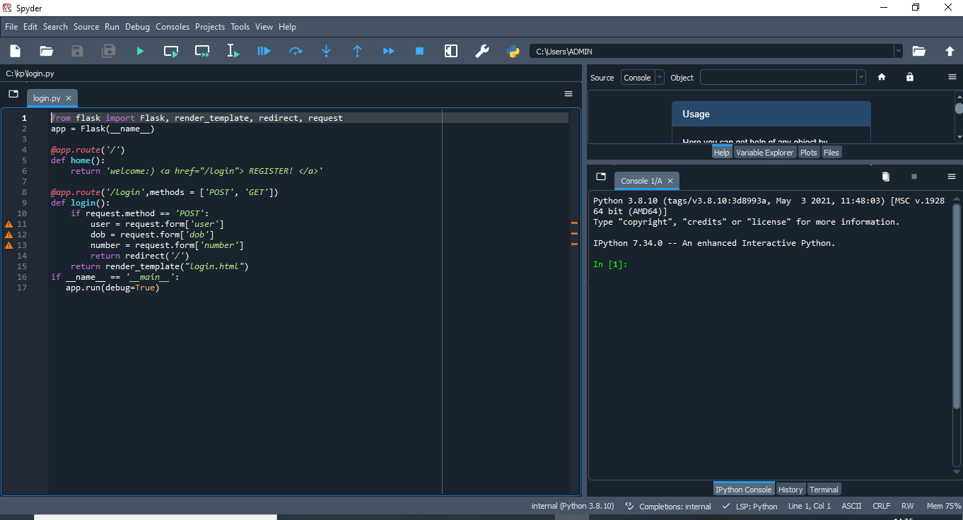

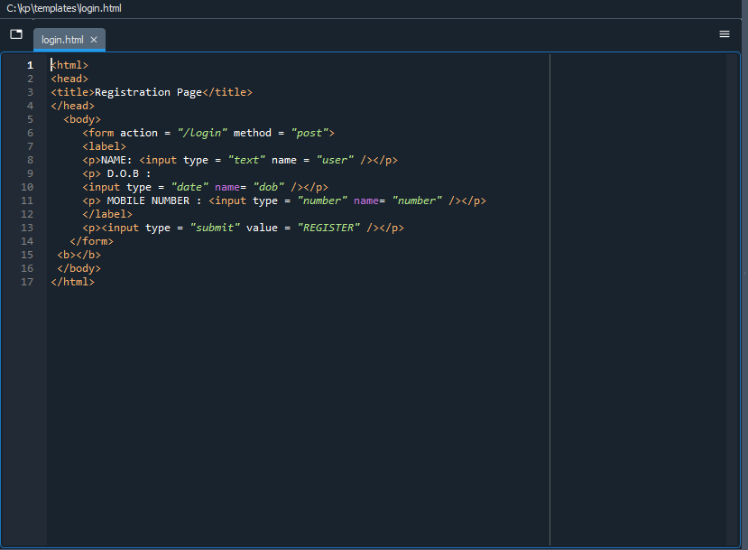

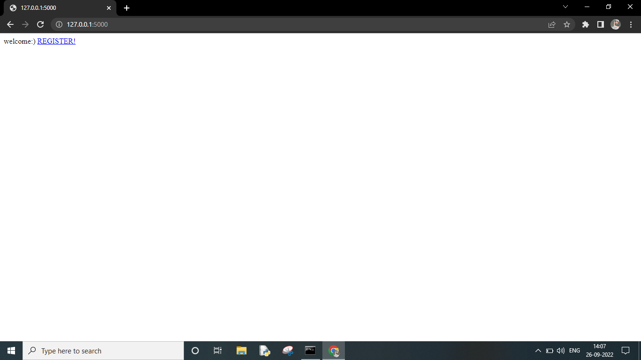

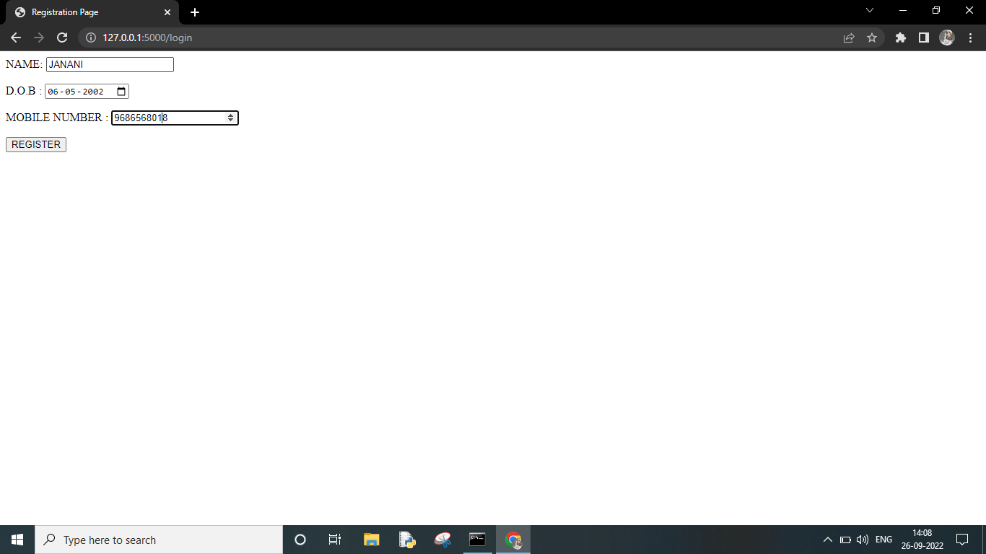

2.**Develop a flask program which should contain atleast 5 packages used from pypi.org**

**Pypi.org**

import camelcase

from jinja2 import Template

import requests

from flask import Flask

import click

import numpy as np

#numpy

arr = np.array([1, 2, 3, 4, 5])

print(" NUMPY ")

print(arr)

print(type(arr))

print("\n")

#click

print(" CLICK ")

@click.command()

@click.argument('_name_',default='guest')

def hello(name):

click.echo(f'Hello{name}')

#requests i

r = requests.get('https://api.spotify.com/')

r.status_code

print(" REQUESTS ")

print(r.headers)

print("\n")

#jinja2

template = """hostname {{ hostname }}"""

data = {"hostname": "core-sw-waw-01"}

j2_template = Template(template)

print(" JINJA2 ")

print(j2_template.render(data))

print("\n")

#camelcase

c = camelcase.CamelCase()

txt = "lorem ipsum dolor sit amet"

print(" CAMELCASE ")

print(c.hump(txt))

print("\n")

if __name__== '_main_'

hello()

